**關於SimSwap**

Reference: <https://github.com/neuralchen/SimSwap>

💬從[DeepFaceLab](https://github.com/iperov/DeepFaceLab)官網看到一個相關的項目：  
【[SimSwap](https://github.com/neuralchen/SimSwap)】：Swapping face using ONE single photo 一張圖免訓練換臉。  
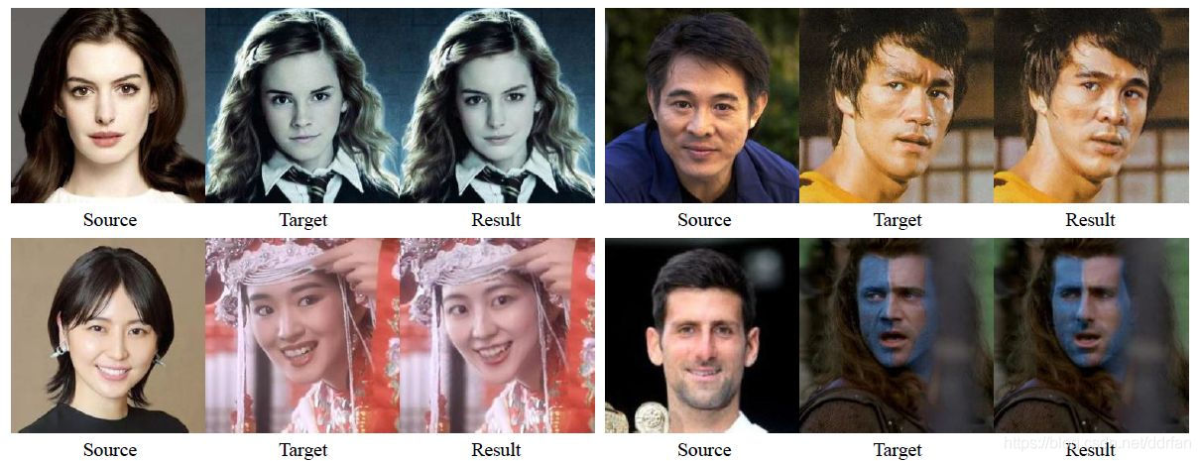

感覺很神奇，百度瞭解到是上海交通大學和騰訊聯合研發的一個框架。SimSwap的意思就是Simple Swap，簡易的換臉。

項目依賴：

* python3.6+
* pytorch1.5+
* torchvision0.9+：進行臉部解析和圖像後期處理
* torchaudio==0.8.0
* cudatoolkit=10.2
* opencv
* pillow
* numpy
* imageio
* moviepy
* insightface0.2+：做臉部識別和對其，進行圖像預處理。

# SimSwap-Colab

https://github.com/woctezuma/SimSwap-colab/#simswap-colab

The goal of this repository is to provide a Colab notebook to apply SimSwap to images.

## Prepare code

%cd /content

!git clone https://github.com/neuralchen/SimSwap.git

%cd /content/SimSwap/

!git checkout main

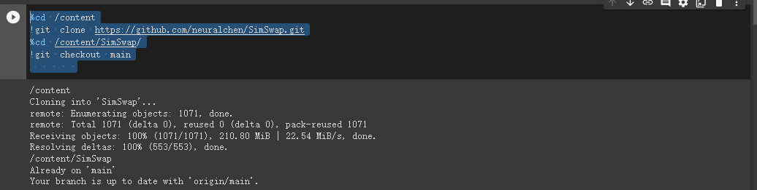

克隆下來的專案目錄，最終目錄結構大概如下：  
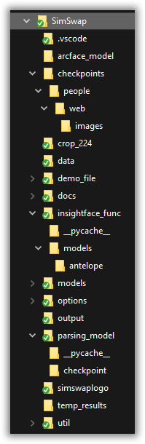

!pip install -q torch==1.13.0

!pip install insightface==0.2.1 onnxruntime moviepy > /dev/null

!pip install googledrivedownloader > /dev/null

!pip install imageio==2.4.1 > /dev/null

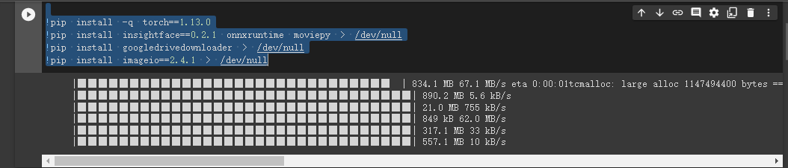

## Prepare models

%cd /content/SimSwap



from google_drive_downloader import GoogleDriveDownloader

!wget -P ./arcface_model https://github.com/neuralchen/SimSwap/releases/download/1.0/arcface_checkpoint.tar

!wget https://github.com/neuralchen/SimSwap/releases/download/1.0/checkpoints.zip

!wget -P ./parsing_model/checkpoint https://github.com/neuralchen/SimSwap/releases/download/1.0/79999_iter.pth

!wget https://github.com/neuralchen/SimSwap/releases/download/512_beta/512.zip

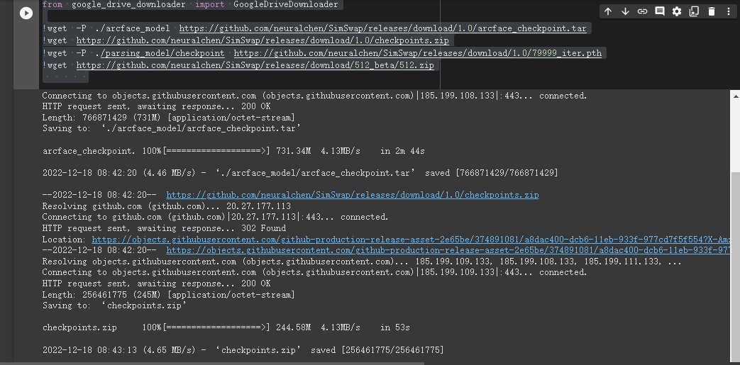

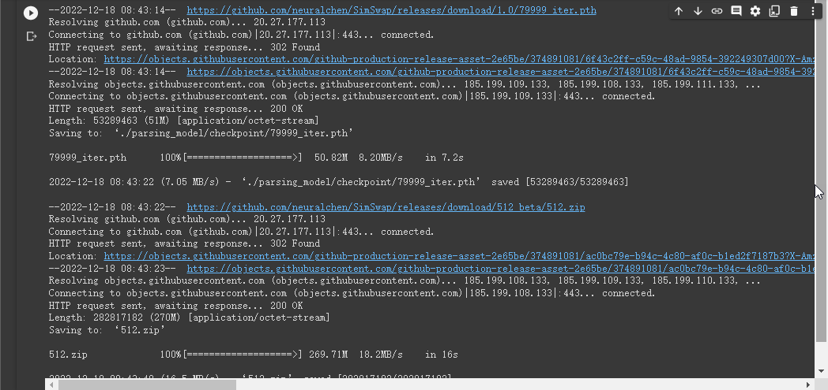

!wget --no-check-certificate \

 https://sh23tw.dm.files.1drv.com/y4mmGiIkNVigkSwOKDcV3nwMJulRGhbtHdkheehR5TArc52UjudUYNXAEvKCii2O5LAmzGCGK6IfleocxuDeoKxDZkNzDRSt4ZUlEt8GlSOpCXAFEkBwaZimtWGDRbpIGpb_pz9Nq5jATBQpezBS6G_UtspWTkgrXHHxhviV2nWy8APPx134zOZrUIbkSF6xnsqzs3uZ_SEX_m9Rey0ykpx9w \

 -O antelope.zip

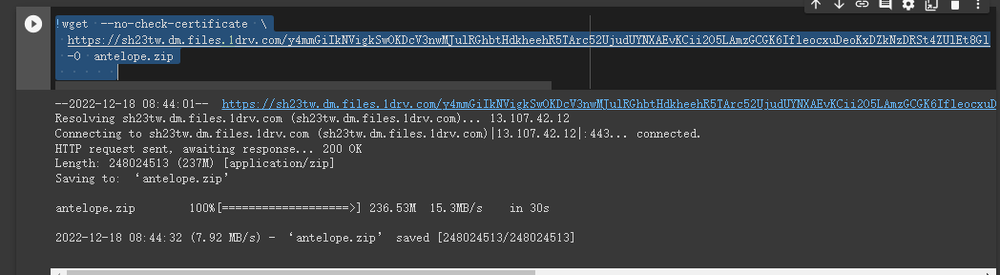

!unzip ./checkpoints.zip  -d ./checkpoints

!unzip 512.zip -d ./checkpoints

!unzip antelope.zip -d ./insightface_func/models/

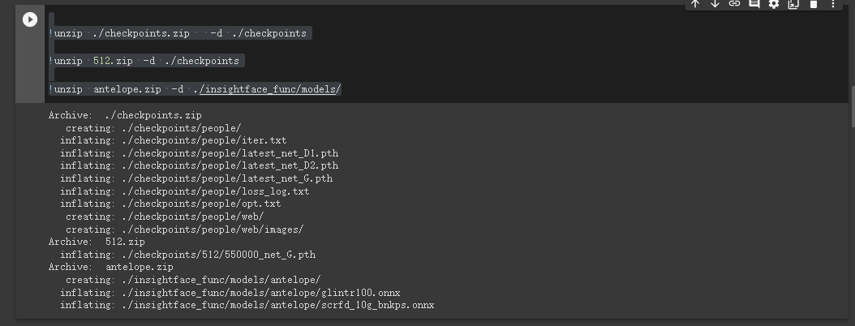

## Prepare data

%cd /content

!wget https://i.imgur.com/QYJOzy7.jpeg -O cpc_ackboo.jpg

!wget https://i.imgur.com/l5MGOws.jpeg -O starwars_meme.jpg

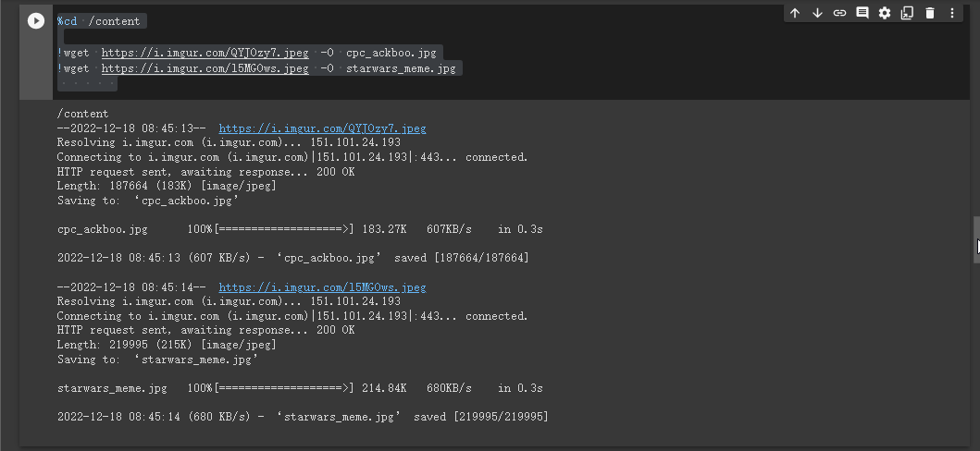

input_fname = '/content/cpc_ackboo.jpg'

output_fname = '/content/starwars_meme.jpg'



### Convert to JPG

Images should not be too large, hence the (arbitrary) limitation of 1024 length.

def get_new_size(img_size,

                 max_allowed_length = 1024):

  if any(max_allowed_length < sz for sz in img_size):

    long_length = max(img_size)

    ratio = max_allowed_length / long_length

  else:

    ratio = 1.0

  new_img_size = [

                  int(ratio*sz)

                  for sz in img_size

                  ]

  return tuple(new_img_size)

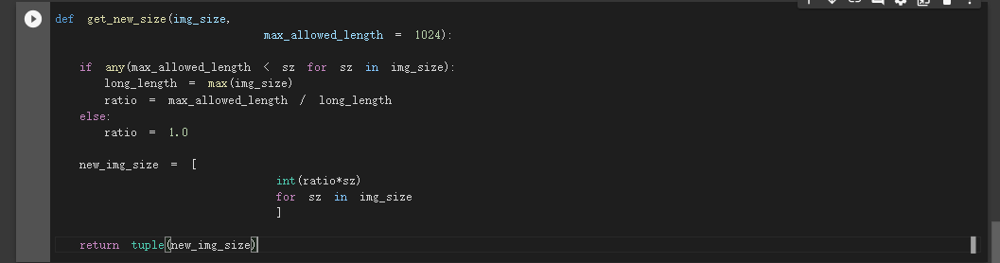

from PIL import Image

allow_resize = False

for fname in [input_fname, output_fname]:

  jpg_fname = fname.replace('.png', '.jpg')

  try:

    img = Image.open(fname)

  except FileNotFoundError:

    continue

  new_size = get_new_size(img.size, max_allowed_length = 1024)

  if allow_resize:

    print(f'Resizing from {img.size} to {new_size}')

    img.resize(new_size)

  print(f'Saving to {jpg_fname}')

  img.convert('RGB').save(jpg_fname)

jpg_input = input_fname.replace('.png', '.jpg')

jpg_output = output_fname.replace('.png', '.jpg')

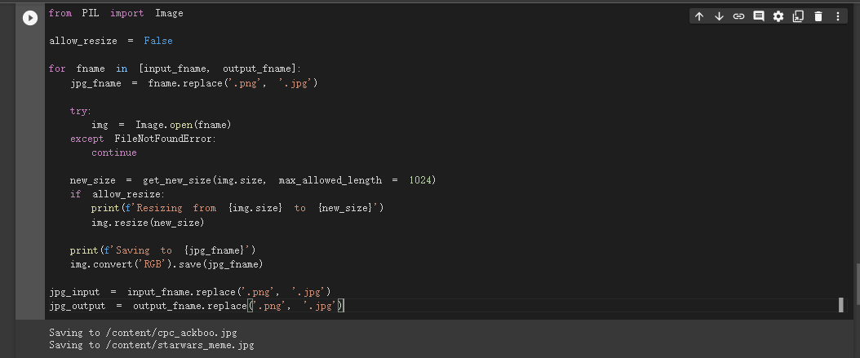

## Run

### Single

%cd /content/SimSwap

%mkdir -p /content/output/single/

!python test_wholeimage_swapsingle.py \

 --no_simswaplogo \

 --use_mask \

 --crop_size 512 \

 --isTrain false  --name people \

 --Arc_path arcface_model/arcface_checkpoint.tar \

 --pic_a_path {jpg_input} \

 --pic_b_path {jpg_output} \

 --output_path /content/output/single/ > /dev/null

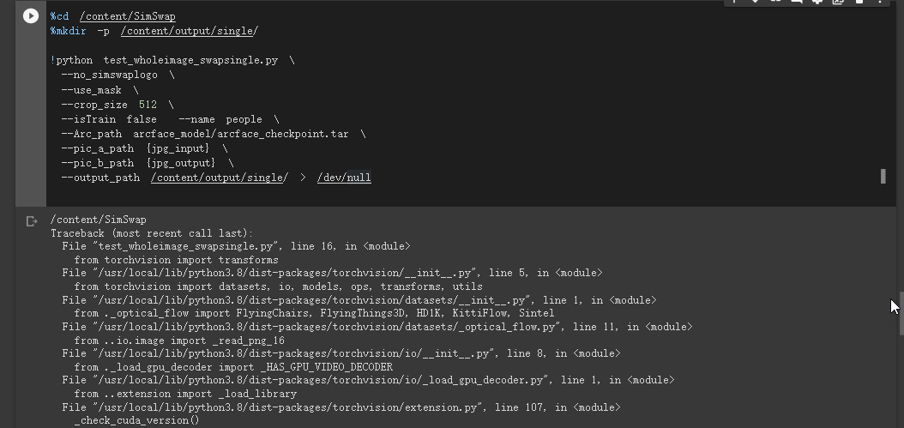

上面的命令，將萊昂納多的臉，換到了發哥的頭上。  
是官方的例子，當然自己執行也一樣效果。

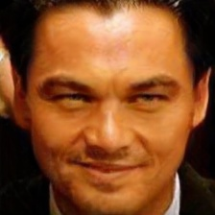

### Multi

%cd /content/SimSwap

%mkdir -p /content/output/multi/

!python test_wholeimage_swapmulti.py \

 --no_simswaplogo \

 --use_mask \

 --crop_size 512 \

 --isTrain false  --name people \

 --Arc_path arcface_model/arcface_checkpoint.tar \

 --pic_a_path {jpg_input} \

 --pic_b_path {jpg_output} \

 --output_path /content/output/multi/ > /dev/null

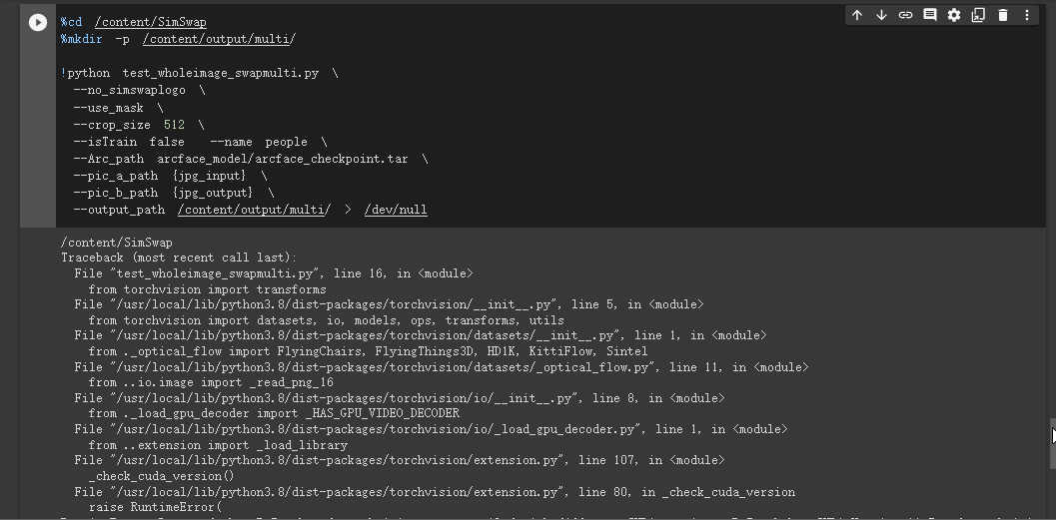

換視頻中所有的臉（非常詭異的效果）

(simswap) C:\SimSwap>python test_video_swapmulti.py --isTrain false --use_mask --name people --Arc_path arcface_model/arcface_checkpoint.tar --pic_a_path ./demo_file/Iron_man.jpg --video_path ./demo_file/multi_people_1080p.mp4 --output_path ./output/multi_test_swapmulti.mp4 --temp_path ./temp_results

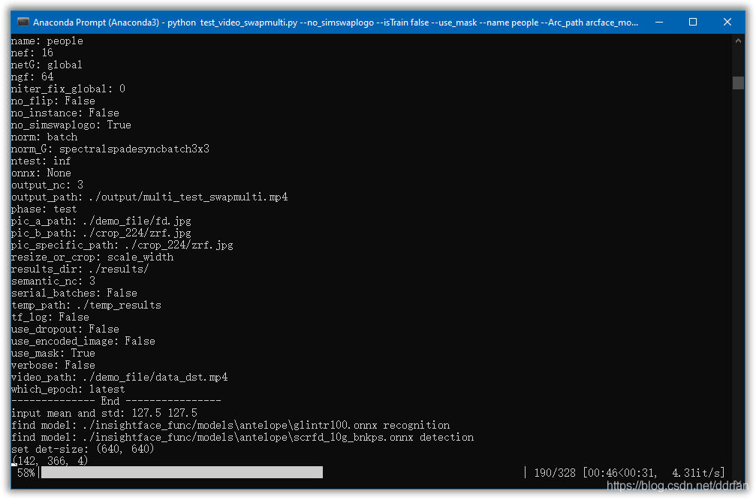  
等進度條走完，基本上就完成了。

還可以多種方式，指定臉換臉，去掉logo等，請看[原文](https://github.com/neuralchen/SimSwap/blob/main/docs/guidance/usage.md)吧。  
大概效果和官方的介紹是一樣的。  
